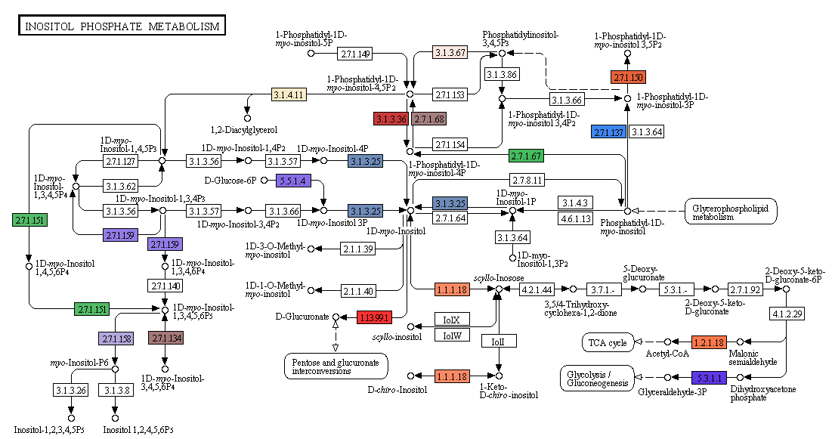
Supplementary File 5. KEGG pathway for Inositol Phosphate Metabolism (map00562). Highlighted EC numbers were identified in our contigs. A total of 41 contigs were involved in this pathway (Supplemental File 4) by encoding different important enzymes. List of enzymes and encoding contigs are given below the figure

EC number | Enzyme | Encoding contigs
EC:3.1.4.11 | phospholipase C | Contig45, Contig22324, Contig23382
EC:5.3.1.1 | isomerase | Contig12868, Contig13025, Contig13300, Contig20659, Contig22093
EC:1.13.99.1 | oxygenase | Contig16924
EC:3.1.3.67 | 3-phosphatase | Contig23246
EC:3.1.3.36 | 5-phosphatase | Contig23746, Contig21364
EC:3.1.3.25 | phosphatase | Contig6267, Contig16743, Contig22397
EC:2.7.1.159 | 5/6-kinase | Contig13496
EC:2.7.1.158 | 2-kinase | Contig9217, Contig21103
EC:2.7.1.151 | multikinase | Contig12115
EC:2.7.1.150 | 5-kinase | Contig14665, Contig15013
EC:2.7.1.137 | 3-kinase | Contig4612, Contig4678, Contig17306
EC:2.7.1.134 | 1-kinase | Contig2323, Contig13496
EC:1.1.1.18 | 2-dehydrogenase | Contig16579
EC:1.2.1.18 | dehydrogenase (acetylating) | Contig18625, Contig21623
EC:5.5.1.4 | synthase | Contig7199, Contig12527, Contig14142
EC:2.7.1.68 | 5-kinase | Contig7869, Contig8149, Contig8973, Contig14665, Contig15573, Contig20703, Contig22924
EC:2.7.1.67 | 4-kinase | Contig7992, Contig18633

